Importing and Stabilizing a Mesh

1. In the top left corner, go to file🡪import🡪mesh and then specify the directory of the mesh files.

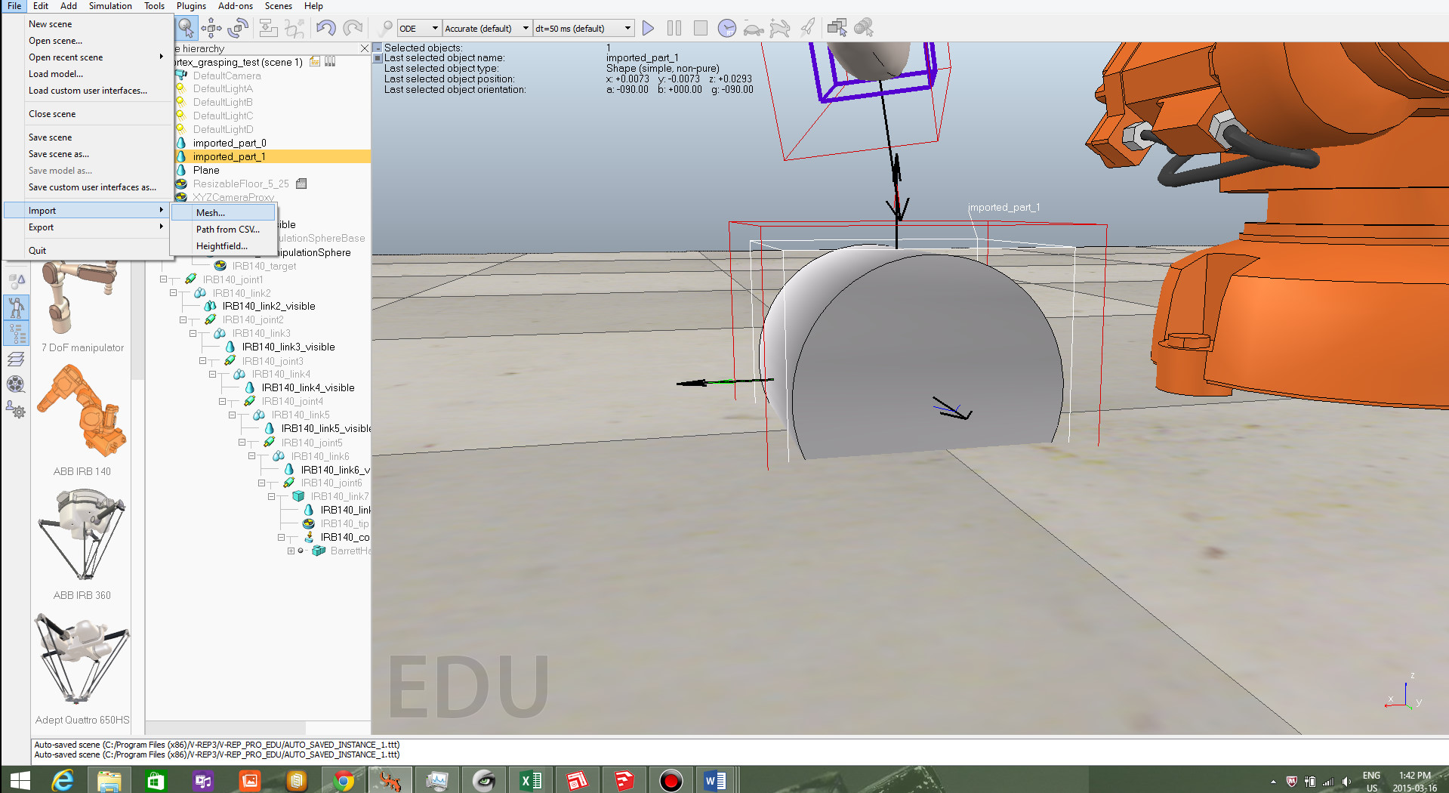

1. Specify a mesh scaling of “1 unit represents 1 centimeter” Leave the mesh orientation as it is. IMPORTANT: do not move/rotate the object until all of these steps are completed.

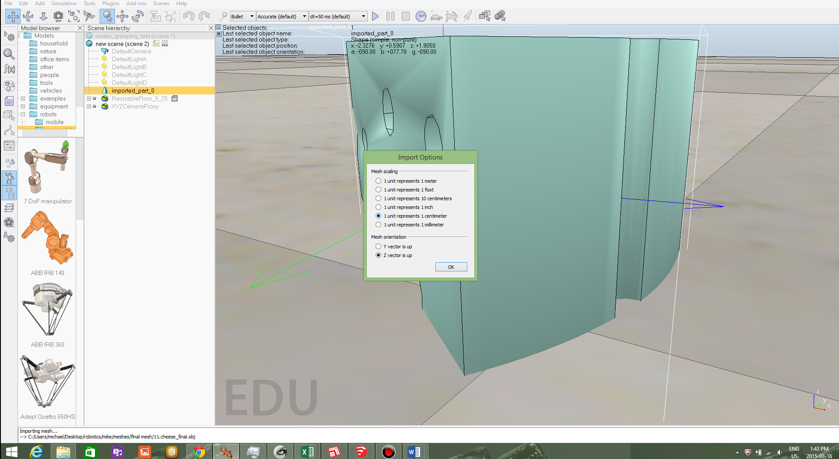

3.Select the object by clicking on it. Then go to the top left tools🡪scene object properties.

4.Select “show dynamic properties dialog”

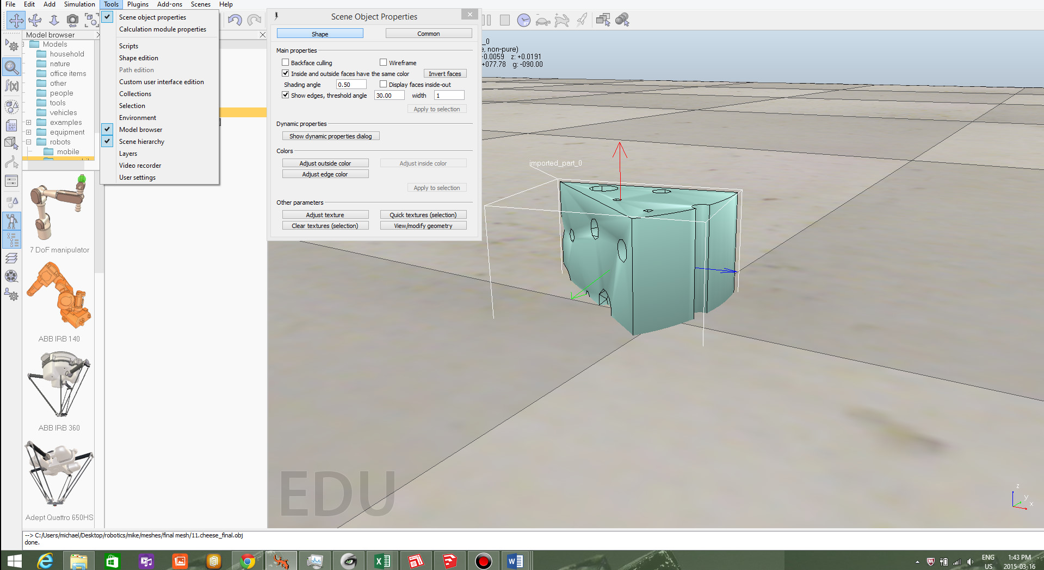

5.Make sure that the “static” box is unchecked And that the “body is respondable” box is checked.

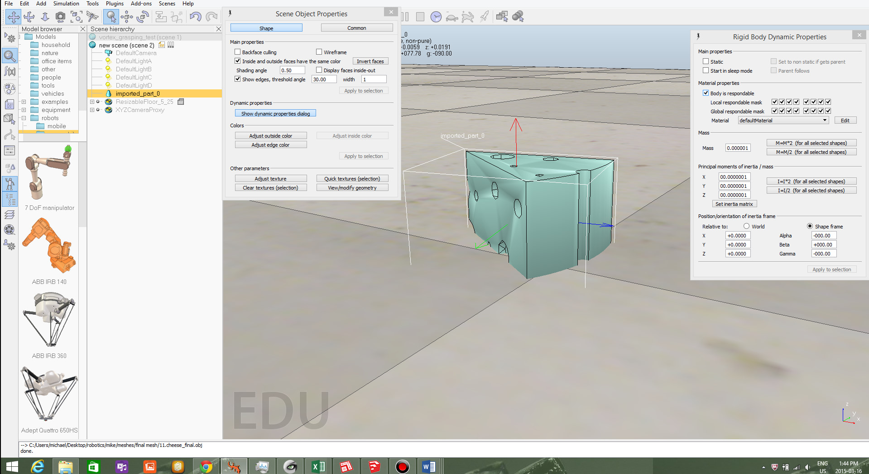

6. Follow the ODE stabilization steps outlined below:

* Once you have your mesh imported and you have inputted the Center of mass and moment of inertia. Click on the mesh and then in the top left corner click on tools🡪scene object properties🡪show dynamic properties dialog

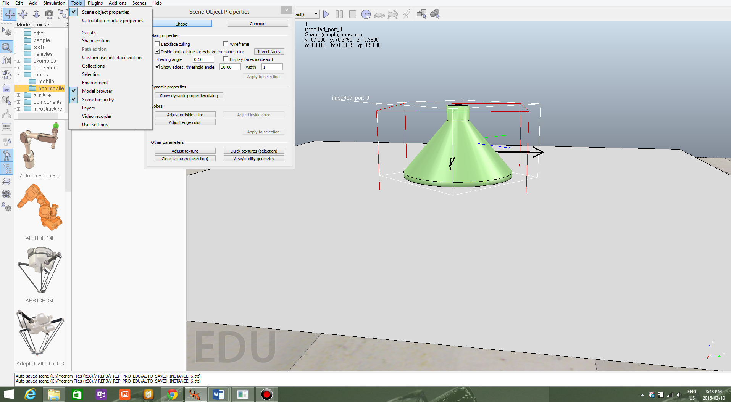

* Next to material, click on the drop down menu and select “HighfrictionMaterial”.

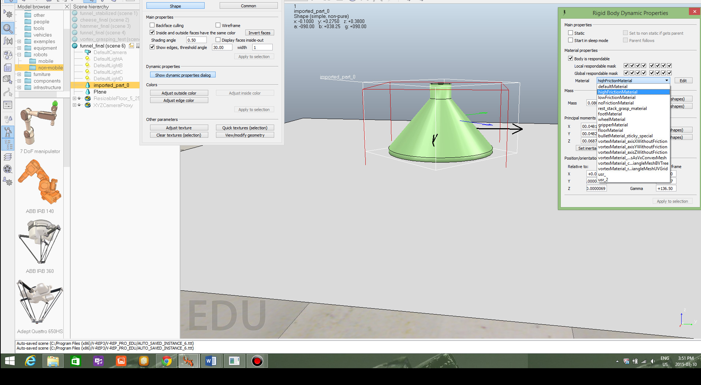

* Next to the drop down menu, press edit and at the top, press “duplicate”.

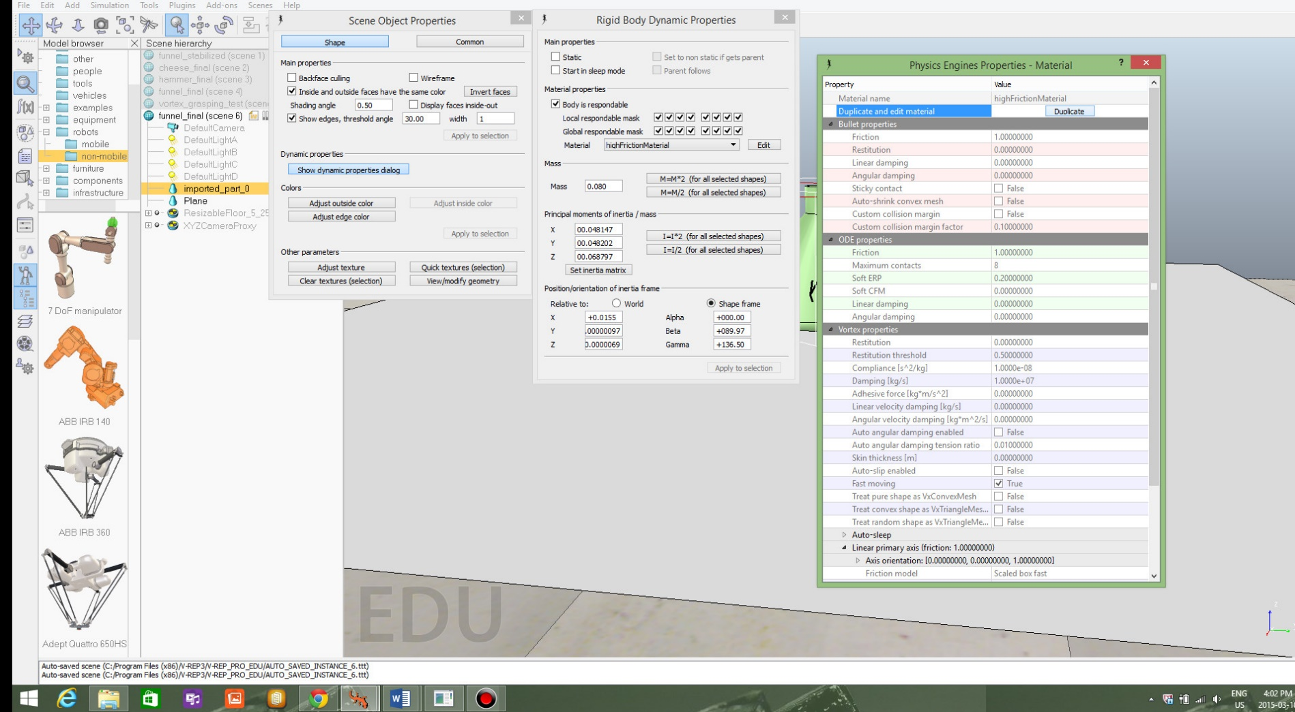

* Scroll down to ODE properties and change the value of maximum contacts to 64.

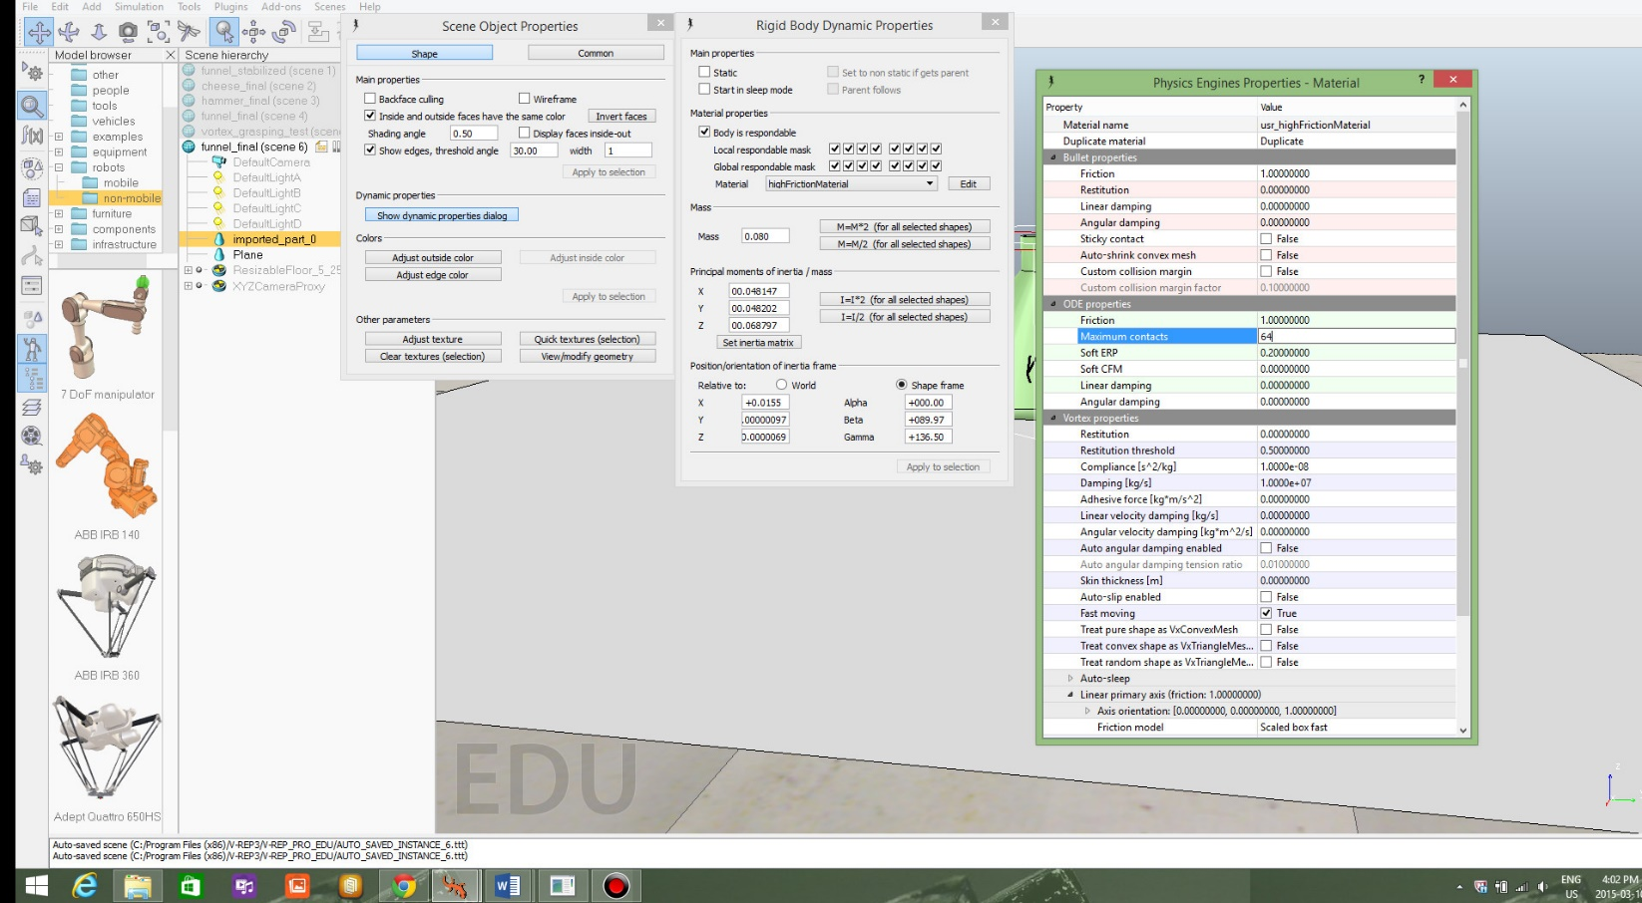

7. Once the ODE stabilization has been completed, go back to the rigid body dynamic properties. Now it is time to insert the mass, Center of mass, and moment of inertia



8. Insert the mass of the object in kilograms. The mass of the object can be found on the word file.( use ctrl+f to find the name of the object)

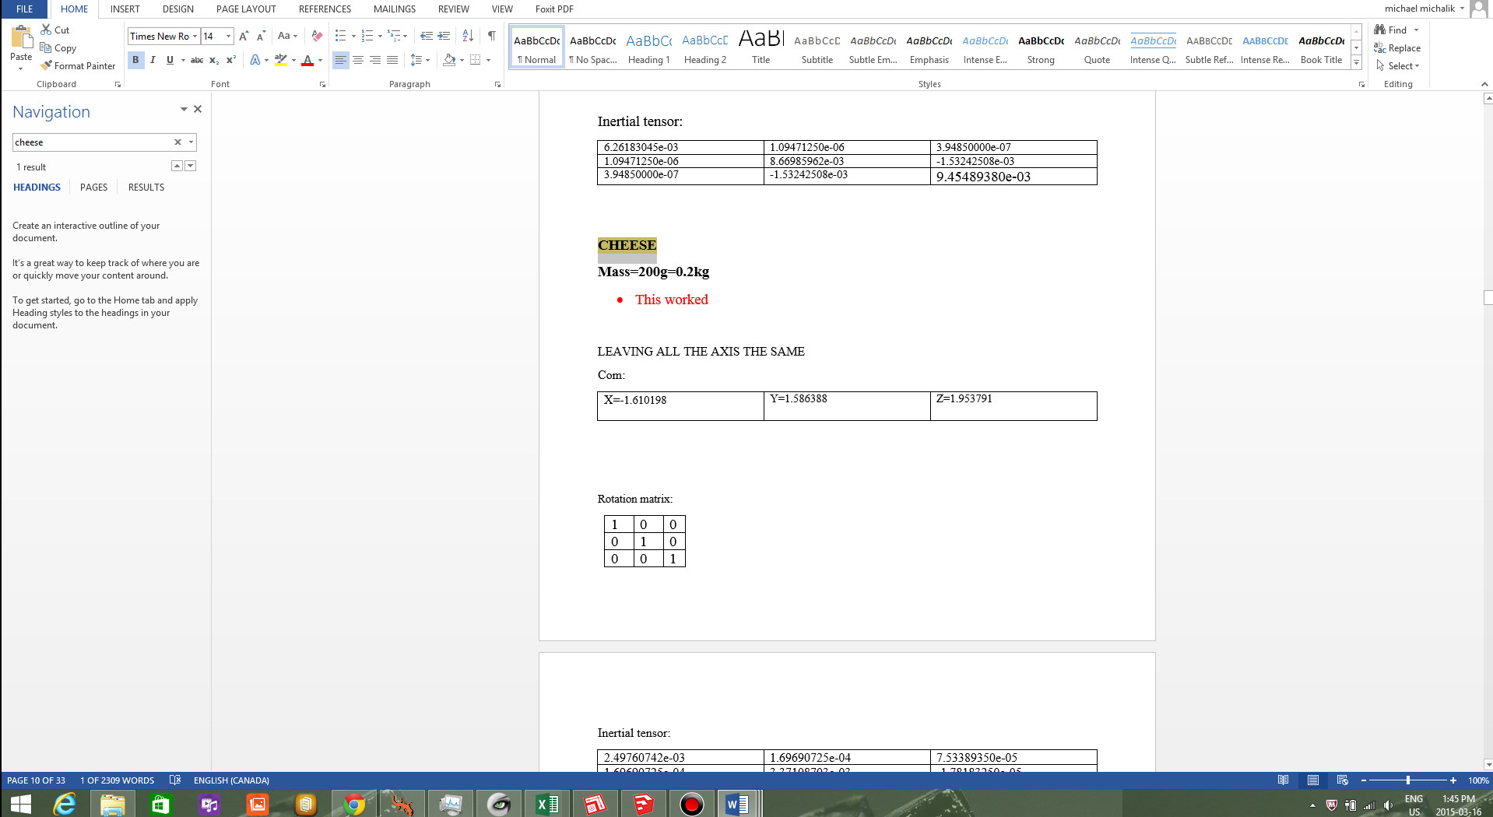

9. Now, under the mass, click on set inertia matrix. At the bottom, make sure that “inertia and COM are relative to absolute frame” is selected.

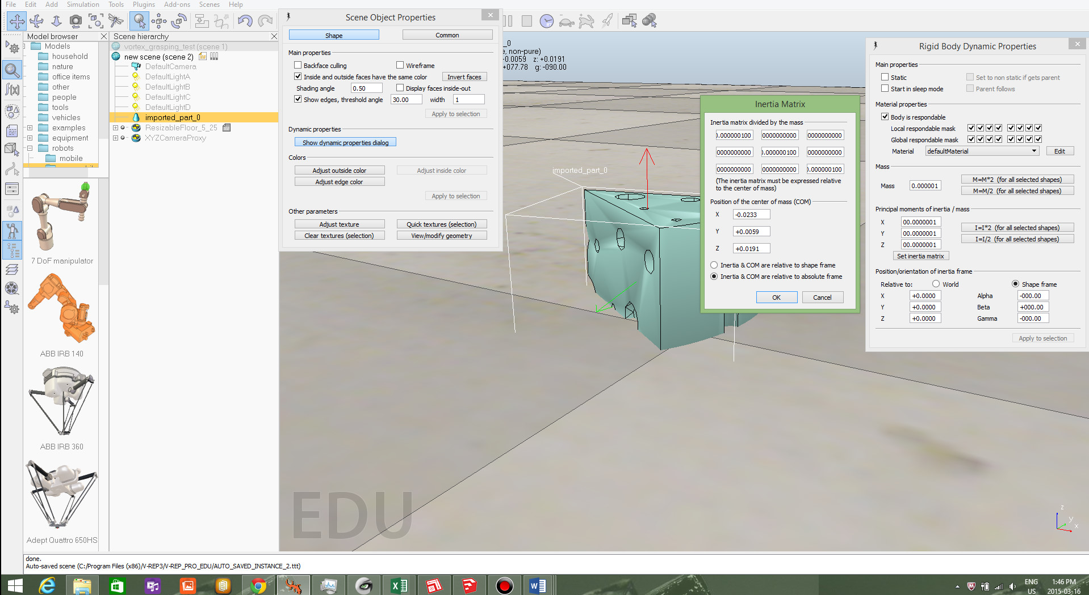

10. Now copy and paste all of the corresponding COM and the inertial tensor from the word file into v-rep. And you are done! Now you are free to move the object.

